**Levitating Ping Pong Balls** 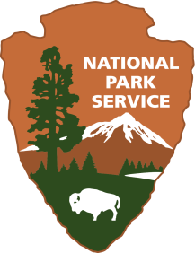

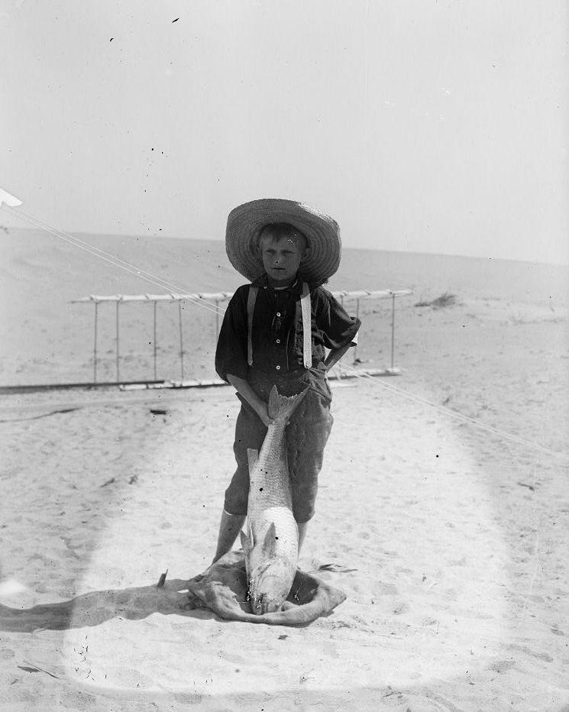**Wright Brothers National Memorial**

|  |
| --- |
|  |

**Location:** Classroom

**Grade:** 4th grade

**Subject:** Science

**Duration:** 60-90 minutes

**Key Vocabulary:** wind, lift, levitation, Bernoulli’s principle,

**Student Materials:**

1 flexible bend straw

3 large paperclips

1 ping pong ball

Tape

Copy of recording sheet

**Teacher Materials:**

Whiteboard/markers

Hair dryer

**Site Significance:**

Before Orville and Wilbur Wright flew their flying machine, they practiced with kites and gliders to learn how wind and lift worked. The location of Kill Devil Hills in Kitty Hawk, North Carolina was instrumental to their eventual success with powered flight. Big Kill Devil Hill provided a gravity assist while the ocean winds of the Outer Banks allowed the brothers to have sustainable lift.

persistence

**North Carolina State Standards:**

**NC 4.P.3** Recognize that energy takes various forms that may be grouped based on their interaction with matter.

**EX.4.P.1** Understand how force affects the motion of an object.

**EX.4.P.1** Predict how forces can change the speed or direction of an object

**Objectives:** Students will construct and use a simple device to demonstrate Bernoulli’s principle and relate it to the “lift” of an airplane.

Students will:

* be able to construct a device with a straw, tape and paperclips
* explore the effects of blowing air through the straw and the movement of a ping pong ball in reaction to the fast moving air
* understand how the reaction of the ball demonstrates Bernoulli’s principle

**Essential Question:** How did the Wright brothers utilize the information they learned from their failures and successes in order to create the first successful powered flyer?

**Method:** Students will use materials provided and work individually within a collaborative group to levitate a ping pong ball. They will also attempt to create a “basket” to catch the ping pong ball when the flow of air stops.

**Background:** The Wright brothers were successful in creating three gliders (1900,1901, 1902) and the first heavier-than-air powered flying machine, the 1903 Wright Flyer. Before the first successful powered flight, the brothers struggled with the problem of inadequate lift relative to the size and weight of the gliders. Using Bernoulli’s principle, information from Lilienthal, and then their own calculations, the brothers changed the wing shape of their 1902 glider by enlarging the wing area and changing its curvature. These adjustments were essential for the first successful flight. Below is a brief outline of the events leading up to the first successful powered flight.

These are the steps the brothers took that led to their success in achieving powered flight. Please note the **bold** print indicates this lesson’s focus.

* Read everything they could find on flight.
* Built and flew 1899 kite to test wing warping.
* Found the windiest locations in the U.S. (chose the Outer Banks of North Carolina)
* Built 1900 glider; flew it first as a kite to test controls; observed how it flew and how it responded to the controls; made adjustments to the controls; then flew and piloted it as a glider.
* **Built 1901 glider; increased the wingspan for better lift; observed how it flew; adjusted the wings; found it didn’t work as predicted.**
* **Realized Lilienthal’s tables were wrong; built wind tunnel; tested 200 different wings; made their own tables.**
* **Built 1902 glider with thinner, longer wings and a rudder; then observed the glider during tests and adjusted it as needed; satisfied with results.**
* Built 1903 Flyer with engine and propellers; tested it; crashed it; repaired damage; then obtained successful flight.

Daniel Bernoulli was a Swiss physicist who lived from 1700 to 1782 and did pioneering work on the motions of fluids (“hydrodynamics”). A modern application of Bernoulli’s Principle is the shape of airplane wings, which in part generate “lift”. **Bernoulli's principle** helps explain that an aircraft can achieve lift because of the shape of its wings. They are shaped so that that air flows faster over the top of the wing and slower underneath. Fast moving air equals low air pressure while slow moving air equals high air pressure. *See suggested video for explanation of activity and Bernoulli’s principle.

|  |
| --- |
|  |

**Suggested Procedure**

**Before the lesson:**

Using some of the read aloud books, discuss the sequence of events leading to the success of the first powered flight. Be sure to discuss that the early gliders did not get very high off of the ground which led the brothers to create a wind tunnel and test over 200 different wing shapes in order to create more lift.

Teachers may want to watch this video before attempting the activity.This video gives the teacher an overview of the activity as well as a simple explanation of Bernoulli’s Principle that can be shared with the students.

<https://www.youtube.com/watch?v=for5lSNGD6o>

**In The Classroom:**

1. Discuss the term “levitate” (float in the air). You may even want to talk about magicians that can make objects or even people appear to levitate. Can students cite any examples of something they have seen levitate? Can they explain why? Show them a ping pong ball and ask if anyone can make it levitate. If so, let them demonstrate.
2. Did the Wright brothers’ kites or gliders levitate? This question could be used to create interesting dialogue about levitation, gliding, and actual powered flight.
3. Ask students what they think “lift” means when talking about levitation or flying?
4. Give each student a straw, ping pong ball and recording sheet. Give them a few minutes to see if they can make the ball float. Many students will be successful but the balls will likely go flying all over the room! It is ok, because they will be engaged! Have students discuss within their group the first question and write down problems they may be experiencing.
5. Give each student 3 paper clips and scotch tape. Ask if they can incorporate these materials to help them. Can students use these materials in any way to help them levitate the ball or to keep the balls from falling when students quit blowing through the straw? Paper clips can be bent if needed. Before students start, have them answer the second question.
6. Observe their attempts giving feedback and encouragement. Remind them that the Wright brothers worked for many years before they were successful. They persevered through many failures before they were successful. You could discuss the fact that even though the Wright brothers worked mainly between themselves, they did reach out to others for help and suggestions. Encourage those that might be having difficulty to look at other models within the classroom to see if they can get ideas. Students may think that is “copying” or “cheating” but remind them that the Wright brothers took ideas of others and expounded on those to create even better models which eventually led up to the successful flight.
7. After giving students ample time to create and explore, have them share their “inventions” with the class. Have them draw their inventions in the space provided on the recording sheet. Pose these questions and if time allows (or on another day) try them out. Does it make a difference if you blow harder or softer through the straw? What if the straw was shorter? What if you put 2 straws together? What if you used a fatter or thinner straw? What might happen if you blow through a paper towel roll? Is there another source that could be used to levitate the ball? Students may come up with a hair dryer or fan.
8. Using a hair dryer, demonstrate Bernoulli’s principle using a ping pong ball. Show that the hair dryer can be pointed at different angles and the ball will still stay within the stream of air. Does the hair dryer remind them of anything that the Wright brothers used? (wind tunnel and strong ocean winds) Will the hair dryer work to “levitate” other objects such as a pencil, piece of paper, popsicle stick, inflated balloon? If time allows, try these out.
9. Explain what Bernoulli’s principle is. (The video suggested in the “Before the Lesson” offers a kid friendly explanation.) How is Bernoulli’s principle seen in the real world? Relate this to the Wright brothers and their wind tunnel testing of over 200 different wing shapes in order to get the most lift. Relate this back to why the brothers decided to experiment with their flyers in Kitty Hawk. (wind). Was the prediction about lift that students made earlier in the lesson correct?

**Post- Activities:**

Have students research “lift” on the internet and write or draw a brief explanation to present to the class. A slideshow presentation could be created to share with the class.

|  |
| --- |
|  |

**Evaluation:** Students may be assessed from teacher observation or from their responses on the recording sheet. If a slideshow or Seesaw was used, those artifacts could be used as evaluation tools.

**Extensions:**

|  |
| --- |
| * Students create their own paper airplanes and explore making different types of wings to see if they can improve the lift or distance flown. Students can measure the distance flown. * Watch “ The Magic School Bus” Taking Flight and discuss what they learned about “lift” <https://www.youtube.com/watch?v=gjHSYdN1JN8&disable_polymer=true> * Students can use this fun interactive online game to change the size and shape of the glider wings and then fly their glider and see the results. Students will be able to go back and make modifications to the glider wings to see if they can achieve a better flight! So fun! Also there are other videos and activities in a simulated Wright brothers’ workshop experience.   <https://airandspace.si.edu/exhibitions/wright-brothers/online/workshop/>   * Students could do an audiovisual recording using Seesaw to explain lift and/or Bernoulli’s principle using their straws and ping pong ball.   https://app.seesaw.me/ |

**Additional Resources**

**Websites:** <http://www.sil.si.edu/ondisplay/flight/intro.htm>

https://www.nps.gov/wrbr/index.htm

**Books:** *Who Were the Wright Brothers?* James Buckley, Jr

*The Wright Brothers’ Glider*  Gerry Bailey and Karen Foster

*You Wouldn’t Want to Be on the First Flying Machine!* Ian Graham

*The Wright Brothers: Inventors Whose Ideas Really Took Flight* Mike Venezia

|  |
| --- |
|  |

**Levitating Ping Pong Balls**

1. **Discuss the results of the experiment with your group? Are you having any problems getting the ping pong ball to levitate? If so, describe the problems you are experiencing.**
2. **What is working well for you at this point during the experiment?**
3. **Can you use the tape and paperclips to help you? Discuss with your group how these materials might be used. What are some ideas you have? Draw and label your idea below.**

|  |
| --- |
|  |

1. **Draw your final “invention” in the space below.**

|  |
| --- |
|  |

1. **Tell me what you learned through this activity.**